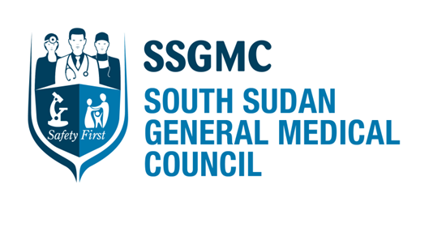

Member of the International Association of Medical Regulatory Authorities (IAMRA).
Member of the Association of Medical Councils of Africa (AMCOA).

ANNUAL REPORT & FINANCIAL STATEMENTS
2017

Contacts:

Ministry of Health Complex
Central Equatoria State
Juba
Republic of South Sudan

Website: www.southsudangmc.org
Email: Info@southsudangmc.org
……….. j.adwok@southsudangmc.org
Tel: … +211955185104
……….. +254722511134

CONTENTS

Our vision | 3
Our mission | 3
Our history | 3
Section 1 – An overview of The South Sudan General Medical Council | 4
About us | 4
Council Members | 5
Our supporters | 6
Section 2 – Governance | 7
Structure & management | 7
Chairperson’s report | 8
Strategic Objectives and Activities | 9
Strategic Objective 1 | 9
Strategic Objective 2 | 15
Strategic Objective 3 | 16
Section 3 – Finances | 21
Non-Audited Financial Reports | 21
Section 4 – Acknowledgements & Way Forward | 22
Acknowledgements & Challenges | 22
Looking to the future | 22

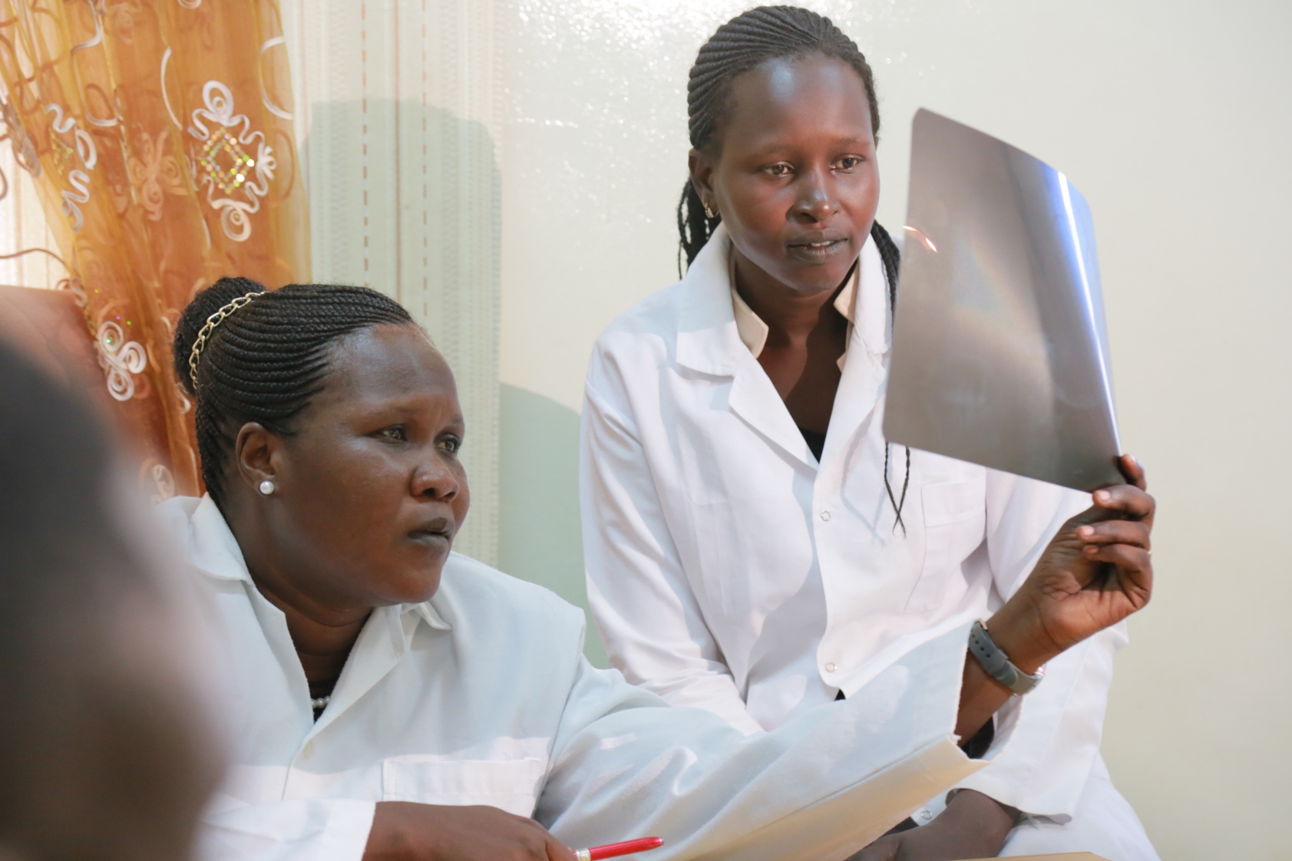

Our vision

Our vision is to be a medical regulatory body that ensures professional practice among Medical Doctors, Pharmacists, Dentists and Health Care Institutions in the interest of patient safety.

Our mission

Our mission is to ensure high standards of education, training and practise among medical doctors, Pharmacists and Dentists by providing oversight to medical training and licensing of health care institutions and providers.

Our History

The SSGMC was established through a Provisional Order, 2014 issued by H.E. General Salva Kiir Mayardit, President of the Republic of South Sudan on the 10th of April, 2014. The 18 members of the board were eventually sworn in seven months later in November of the same year. The provisional order was passed by parliament several months later and is currently referred to as the South Sudan General Medical Council Act.

Section 1- An Overview of the South Sudan General Medical Council

ABOUT US

The South Sudan General Medical Council (SSGMC) is an autonomous body responsible for the registration and regulation of medical, dental and pharmaceutical professions as well as regulation of health care institutions and services in the country. The SSGMC registers and licences medical doctors, dentists and pharmacists in both the public and private sectors. It also registers and licences health care organisations including NGOs, private and public hospitals, nursing homes, clinics and health care related teaching institutions.
Our Core Values

- We maintain efficient, transparent and professional regulatory services that guarantee respect for the public and uphold the dignity of doctors.
- We set standards for the treatment of patients with fairness and equitably.
- We encourage excellence and innovation in institutions that we regulate.
- We make independent, informed and objective decisions for which we are accountable.
- We strive to enhance trust between patients, doctors and the medical council.

Patron

Gen. Salva Kiir Mayardit, President of the Republic of South Sudan,
is the Patron of the South Sudan General Medical Council.

Council Members

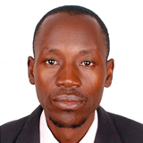 | 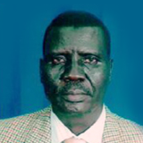 | 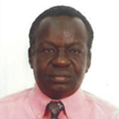 | 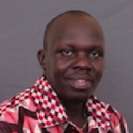 | 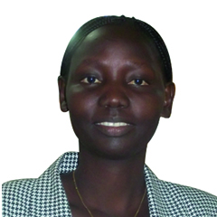
Dr. Emmanuel Oryem Lino  Member | Dr Benjamin Malek  Member | Dr. Jino David Lado  Member | Dr. Edward Ermugo Luka  Member | Dr. Margret Betty Eyobo  Member// Acting Registrar
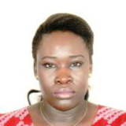 |  | 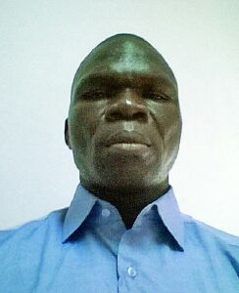 | 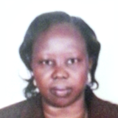 | 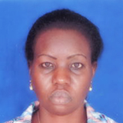
Dr. Buchay Othom Rago  Member/ Acting Finance Director | Dr.Mabior Makopi Deng  Member | Dr. Anthony Lupai Simon  Member | Prof. Rose Ajak Costa  Member | Dr. Victoria Achut  Member
 | 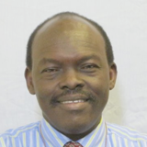 | 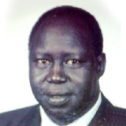 | 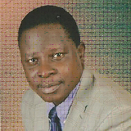
Prof. John Adwok  ChIairperson | Prof. Mayen Achiek  Deputy Chairperson | Prof. Peter Adwok Otto  Member | Dr. John Rumunu  Member | Dr. Dario Kuron  Member
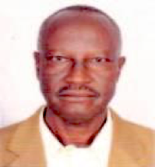 | 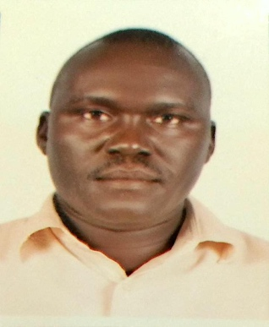 | 
Dr. Santino Tito  Member | Dr. Simon Lado Gore  Member | Dr. James Vasilli

OUR SUPPORTERS


International Finance Corporation
Health in Africa Initiative
Health, Nutrition & Population

Areas of support Included:
- Continued support of website design and hosting in 2017.
- Supported two SSGMC members to attend the AMCOA annual meeting in Cape Town, 2017.
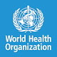 World Health Organisation, South Sudan
Areas of Support included:
- Situational Analysis for the SSGMC in 2015. The WHO also supported 3 SSGMC members to attend the 20th AMCOA meeting in Malawi, 2016. One member failed to attend.
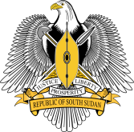Office of the President, Republic of South Sudan
Areas of Support in 2017 included:

- The first post-internship registration examination for medical doctors in 2017 as well as the second quarter meeting of the SSGMC through the office of the Executive Director.
- The Office of the Vice President sponsored the last quarter 2017 SSGMC meeting.
- The Minister of Petroleum and Mining sponsored the second post-internship registration examination in 2017.
- The Director General (requested anonymity) of a Government Ministry partially supported the chairperson to attend a meeting of the International Association of Medical Regulatory Authorities in London, 2017.
- All support and services were officially acknowledged in writing and appear in the SSGMC statement of accounts for 2017, included in this report.

SECTION 2 | GOVERNANCE

STRUCTURE & MANAGEMENT of the SSGMC

Most of the challenges experienced in 2016 persist. The SSGMC has not yet been able to recruit, employ and train staff to carry out its day to day duties including administrative, inspection, registration, licensing and other regulatory duties. On appointment and swearing in of the SSGMC members in November 2014, there was no start up budget allocated making it impossible to initiate recruitment activities with the small sum advanced then y the Ministry of Cabinet Affairs. Our efforts to recruit the Secretary General to run the organization and a Registrar to handle the regulatory functions failed due to lack of funding. Currently the SSGMC is run by the Council members in their free time. The Chair doubles as the Secretary General with the help of a core group of active council members who cover the registration, accounting and other activities on a voluntary basis.

Our proposed organizational structure is as below but we do not have a single employee to date. Our secretariat and administrative functions are run by a core group of council members who have sacrificed their time from their jobs to carry out council work at no pay.

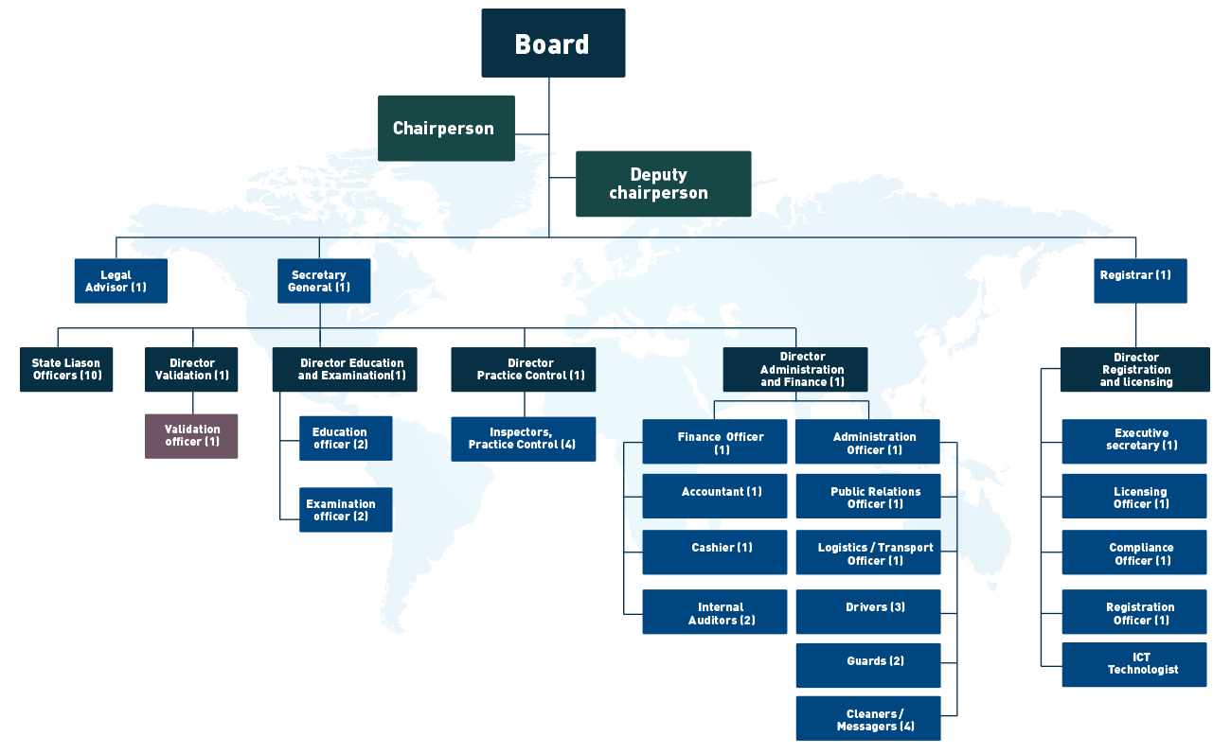

CHAIRPERSON’S REPORT

Prof. John Adwok
Chairperson, SSGMC

Once again, I have the unpleasant but mandatory task to present the third Annual Report since the establishment of the SSGMC. The challenges with the day to day activities have persisted through 2017 due to lack of financial and human resources necessary for effective and efficient regulatory activities. However, we remain optimistic in our outlook as we perform basic regulatory tasks under extremely difficult circumstances. We fully appreciate that the fiscal issues affecting the country as a result of the ongoing civil strife and complex emergencies must come to an end someday. Unfortunately, there are dissenting voices in our health care system and beyond who believe we could be performing better than we are at the moment even without a single employee and no tangible resources. They are probably overestimating our abilities and hopefully not questioning our commitment to selflessly and voluntarily serve our country.
We have continued to improvise and make the best use of the available resources to us with some assistance from health care partners and well-wishers in our government. Our website is now faster, mobile phone friendly and a full updated register of doctors, dentists and pharmacists has been uploaded to the website in 2017. The SSGMC has also established itself as a key member of the international and regional regulatory authorities by attending and participating in meetings and conferences. Most of our progress this year has come about through the support of the Office of the President of the Republic and well-wishers in the government. We are sincerely grateful for this support as our visibility on the website and regular participation in regional and international conferences have increased the recognisability of our nascent country in the medical regulatory field.
Despite all the seemingly insurmountable challenges, the SSGMC has established its authority to set standards for medical, dental and pharmaceutical practice in the country. In line with our mandate to ensure that doctors and health care institutions deliver a high standard of care with emphasis on patient safety, we have pursued our short-term strategic plan and can confidently claim significant achievements. Admittedly, it has not been possible to achieve all our strategic objectives but we remain well positioned for future activities guided by our vision, mission and core values in spite of the fiscal challenges the country continues to face since 2013. Our main focus now is to improve the quality of health care by ensuring the health care providers and institutions meet basic internationally accepted criteria in their practises.
There is still rampant negligence and overt malpractice by ‘doctors’ with unverified qualifications that require the intervention of an empowered regulatory authority. This has continued to erode trust in the health care system with many of our citizens still preferring treatment outside the country. The practise of seeking treatment abroad at government expense has continued to be abused in the process with devastating results to our fragile economy. The SSGMC intends to continue its efforts to regain public confidence in the healthcare system by closely monitoring standards of medical professionalism.

Prof. John Adwok, MBBS, MMED (Surg,), FCS(ECSA), FRCS, FACS, PhD.
Consultant General and Endocrine Surgeon.
Chairperson, South Sudan General Medical Council.

STRATEGIC OBJECTIVES AND ACTIVITIES

The SSGMC strategic plan for 2015 – 2017 was underpinned by its Vision, Mission and Core Values which hopefully will continue to guide its strategies and operations during its term in office until the end of 2018. The plan was circulated to healthcare partners who continue to support us (albeit to a lesser degree), Ministry of Cabinet Affairs, Ministry of Health, Ministry of Justice, Faculty of Medicine, University of Juba (U.o.J) and other interested parties. This 3-year strategic plan covers our tenure in office and slightly beyond and was developed based on findings of an expert evaluation process of the regulatory environment in South Sudan at the time. We discuss below where we are on our strategic journey using a tabular summary. The 2017 entries are highlighted in green in the various columns. The yellow highlights are 2016 entries for comparison.

Strategic Objective I

To establish an efficient and functional Medical Council that is responsible for all matters relating to the practice of medicine in the Republic of South Sudan.

The output indicators and means of verification of strategic objective 1 are summarized in Appendix 1 of the annual report. Lack of resources continued to negatively affect all activities including recruitment, purchase of equipment and training. The only training that took place in 2017 happened during workshops when council members attended international and regional meetings and conferences through partner support.

The SSGMC continues to liaise and network with other regulatory bodies in Africa and beyond and has maintained its membership of the Association of Medical Councils of Africa and the International Association of Medical Regulatory Authorities in spite of the high membership costs. This collaboration has already opened up opportunities for capacity building of the council membership and staff in future.
Objective | Activities | Timeline | Inputs | Budget (SSP) | Output | Indicator | Means of verification
1.0 To recruit senior Medical Council officials, and administrative and support staff | 1.1 Recruitment of the Secretary General  1.2 Recruitment of the Registrar  1.3 Recruitment of 38 administrative staff  1.4 Recruitment of 9 support staff | July 2015 – June 2016  We are in 2017 now | Advertisements,  Interview Board  No applicants interviewed yet in spite of interest. | 1,672,992  Funds not disbursed | Senior, Administrative and support staff of the Council are recruited  No staff recruited to date due to lack of resources and budgetary challenges  Encore | Number of staff recruited and available per positions stipulated  Nil  Nil | Interview reports and payroll  Council activities run by volunteer council members at present  Status quo
2.0 To develop website for the Medical Council within three months | 2.1 Develop logo and seal of the Council  2.2 Develop prototype of the website  2.3 Confirmation of the design by Council members | April – June, 2015  2-16-2017  A lot of work gone into the website development | -provisional order  -Written vision, mission and values  - application forms and other documents  Completed | Supported by HIA  Achieved in 2016. | Website developed and documents uploaded  Ongoing process. The website is 90% functional with all council documents uploaded.  Website fully functional by December, 2017 | Website launched for public access  Confirmed  Confirmed in 2017 with further improvement and mobile phone compatibility. | SSGMC website accessible and updated at all times  Yes with minor limitations.  Better than 2016
3.0 To acquire a piece of land for the construction of a permanent Medical Council premises by the end of 2015 | 3.1 Application to Central Equatoria State Ministry of Physical Infrastructure  Submitted severally in the last 3 years | April - December, 2015 | Application letter, fees for land acquisition | 55,000  No funding | Land acquired  No land or premises allocated yet in spite of repeated appeals.  No land or premises allocated to date | Size of land acquired  Non | Land lease and related documents  Non  Non
4.0 Training of Council members on roles and responsibilities pertaining to their assignments starting from Sept. 2015 | 4.1 Workshops for all members of the Council  4.2 Workshops for the various committees of the Council  4.3 On-the-job training for Senior Council officials | September 2015 – September 2016 | Financial resources, facilitators and other experts | 957,600  No funds availed | Council members trained  Council staff trained  No training has taken place yet due to lack of staff and resources.  No formal training has occurred except during workshops. | Number of Council members and staff trained  Two members partially trained at workshops | Workshop and training reports  Available
5.0 To procure vehicles for the functions of the Council | 5.1 Procure 3 Prado vehicles  5.2 Procure 2 Land Cruiser Hardtop (5 door)  5.3 Procure 1 Land cruiser 13-seater hardtop  5.4 Procure 1 Land cruiser pick up | July 2015 – June 2016 | Financial resources, bidding process through advertisements | 4,380,000  No funding | Vehicles procured  No vehicles procured yet due to lack of resources.  Status quo. No vehicles purchased. | Number of vehicles procured and distributed | Reports of bidding, financial transactions and delivery  Non
6.0 To procure office furniture, for the functions of the Council | 6.1 Procure office furniture | May – December, 2015 | Financial resources, bidding process through advertisements | 550,000  No funding | Furniture and equipment procured  Non  Still non in 2017 | Number of furniture and equipment procured  Non | Financial report and updated asset register.  Available
7.0 Procure V-SAT and ICT equipment for the functions of the Council | 7.1 Procure ICT equipment  7.2 Procure VSAT and its accessories | May – December, 2015 | Financial resources, bidding process through advertisements | 357,500  No funding | ICT equipment procured  Non  Non. Secretariatand Chair use own computers | Number and types of ICT equipment procured  Non | Financial report and updated asset register
8.0 Printing and dissemination of South Sudan General Medical key documents and brochures deemed essential | 8.1 Printing of the Provisional Order  8.2 Printing of brochures  8.3 Printing of other asserted administrative documents | May – July, 2015 | Financial resources, fees for designing or adapting the documents | 1,060,000  No funding or activity in 2017 | Medical Council documents in place  Partially  Status quo except for original documents obtained with HIA support | Number and types of documents produced  Letter heads, complimentary slips and folders  Licenses, registration certificates etc |  | Inventory list and delivery notes  Available  Available
9.0 Sensitization of healthcare providers and the public on SSGMC | 9.1 Sensitization of medical doctors, dentists and pharmacist of SSGMC  9.2 Sensitization of the regulatory roles of the | March 2015 – March 2017 | -Airtime for TV and Radio  -Financial resources for conducting seminars  Limited airtime through interviews | 4,309,650  No funding | The public and medical practitioners are sensitized of the regulatory functions of the GMC  Web site exposure onlyt | Number of TV and radio sessions conducted & number of seminars and participants who attended.  Non in 2017 | Recorded videos and audios and workshops/seminars reports.  Non in. 2017
10.0 To Disseminate South Sudan General Medical Council’s promotional literature to relevant national ministries, academia and institutions | 10.1 Disseminate GMC promotional literature to relevant authorities | June – December 2015 | -Financial resources  -printed material  Non  Non | 250,000  No funding | Materials distributed to ministries, academia and institutions  Non  Annual report in preparation will be disseminated | Number and types of documents disseminated | Reports of the activity
11.0 To undertake exposure visits to selected countries to learn about functions and experiences of similar Medical Councils and Medical Boards | 11.1 Exposure visit to Kenya  11.2 Exposure visit to Zimbabwe  11.3 Exposure visit to……………… | September 2015 – July 2016 | -Preparation of papers about SSGMC  -Tickets and per diem for participants  Non  Not implimentd | 900,000  No funding | Exposure visits undertaken  Not achieved  Non | Number of Members in each visit and countries visited | -Trip reports  And reports or minutes of debriefing meetings
12.0 To participate in Regional and International Conferences and meeting of Medical Councils or Boards | 12.1 Participation in conference of African Region  Yes  12.2 participation in conference of International Association of Medical Authorities (IAMRA).  Yes | August 2015 – May 2017 | -Preparation of papers about SSGMC  -Tickets and per diem for participants  IAMRA conference attended by Chairperson at own cost | 1,080,000  No direct funding | SSGMC participated in Regional and International Conferences of Medical Councils or Boards  Yes. Two members attended the AMCOA meeting in South Africa | Number of conferences  Three conferences funded by partners HIA & WHO  One regional conference funded by HIA Initiative  One IAMRA conference in London | Trip report and minutes of debriefing meeting  Available  Reports available
13.0 To orient State Authorities, Ministries of Health and other relevant ministries on the South Sudan General Medical council’s functions. | 13.1 Orientation of State Governors once  13.2 Orientation of State legislators once  13.3 Orientation of State Ministries of Health once  13.4 Orientation of other State Ministries once | April 2015 – April 2016 | -briefing documents  - Tickets for flight of road transport  -per diem  Ongoing process limited by lack of resources and staff  No activity in 2017 | 440,000  No funding | Governors, State Legislators and Ministries are briefed on GMC functions  Non | Number of Officials, legislators and ministries contacted | Trip reports  Non
14.0 To Orientate National and International non-governmental organizations on the South Sudan Medical Council Provisional Order, 2014. | 14.1 Conduct one orientation workshop for National NGOs  14.2 Conduct one orientation workshop for International NGOs, Bilateral, Multi-lateral and UN agencies | August 2015 – February 2016 | -SSGMC Provisional Order 2014  - Financial resources for meetings  Limited to a few mainly WHO and World Bank  No activity in 2017 | 145,000  Non funding | Orientation done to National and International NGOs and Bilateral, Multi-lateral and UN agencies  Obtaining some support with conferences  No activity | Number of meetings conducted and participants | Reports of briefings, seminars or meetings
15.0 To organise workshops and seminars for private sector healthcare providers to acquaint themselves with the regulatory functions of the SSGMC | 15.0 organize 2 workshops and seminars for private sector health care providers | July 2015 – July 2016 | SSGMC Provisional Order 2014  - Financial resources for meetings | 478,850  Non funds | Orientation done for private sector health care providers  Not achieved  Status quo | Number of workshops and seminars conducted  Non | Reports of workshops and seminars  Non generated
16.0 Development of plan and budget for SSGMC premises | 16.1 architectural design and bill of quantity | September 2015 – February 2016 | - Financial resources | 35,000  No funding | Design and BOQ completed  Not achieved  Non | Design and BOQ completed place | Hard and soft copies of the design

Meetings, Symposia and Conferences Attended in 2017

- The 21st Annual Conference of the Association of Medical Councils of Africa(AMCOA) was hosted by the Health Professions Council of South Africa at the Spier Wine Estate, Stellenbosch, Cape Town, South Africa from 21- 25 august 2017.

The focus of this year’s conference was on the advancement of technology and medical regulation in the 21st century. Interactive sessions focused on sharing of country experiences and group session in the following areas
i. Medical technology from the stethoscope to the robot doctor - South Africa
ii. Regulation across jurisdictions - Uganda
iii. Regulation of electronic or digitized medicine - Rwanda
iv. Telemedicine - Lesotho
v. Use of social media in healthcare - Ghana
vi. Modernization of regulation in relation to team based delivery care - Malawi
vii. Technology in chronic care - Seychelles
viii. Litigation – who is liable the doctor or the machine - Kenya

Two members of the SSGMC attended the AMCOA 21st Annual Meeting in South Africa. The team was participating for the second time as full members of AMCOA. The 2018 meeting will be held in Ghana in which the SSGMC will be expected to attend and participate.

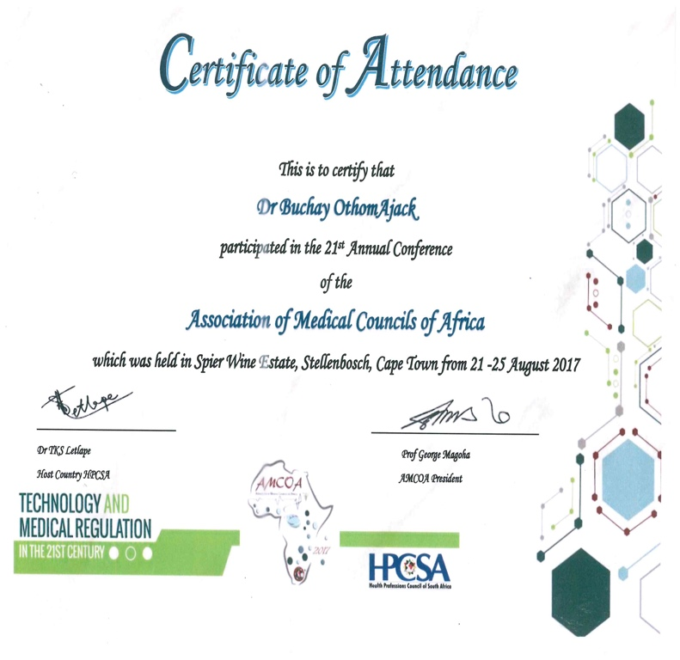

- IAMRA Symposium on Continuous Competence systems---measuring their impact and value, October 5-6, London, United Kingdom, 2017

This was the second international meeting in which the SSGMC participated and was hosted by the General Medical Council (GMC). The conference was attended by the chairperson during which he participated actively in the conference proceedings and networked with other regulatory authorities.

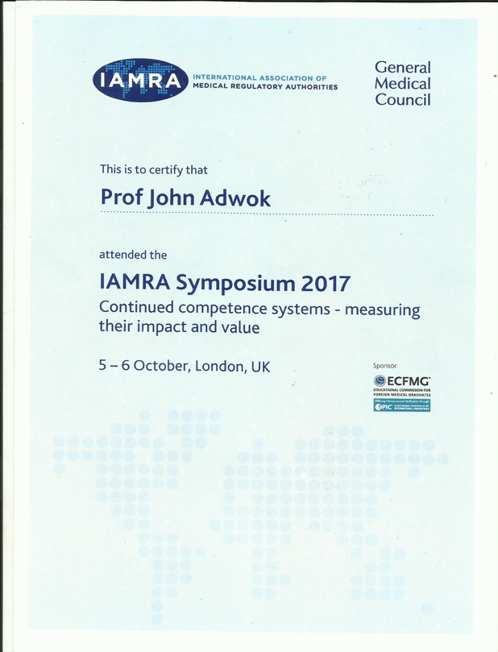

The next IAMRA conference will be in Dubai, United Arab Emirates, August, 2018. The SSGMC will participate in this important meeting if resources become available.

- The 7th Annual Nursing Symposium on Patient Safety, Nairobi Hospital, 4th November, 2017.

The Chairperson gave a keynote address on “Patient Safety” as an invited guest speaker. The Presentation has been uploaded to the SSGMC website.

- Kenyatta National Hospital/ University of Nairobi Symposium on Medico-legal issues in Health, 8th December, 2017.

The Chairperson presented a scientific paper on “Malpractice Liability and Defensive Medicine” during the symposium. The presentation has been uploaded to the SSGMC website.
Strategic Objective II

To develop all the necessary documents pertaining to registrations, licensing, inspection, training and setting up of standards of providing health care in the country.

The second strategic objective is to develop all the necessary documents pertaining to registrations, licensing, inspection, training and setting up of standards of providing health care in the country. Many medical practitioners have either registered in Sudan before the independence of South Sudan or in their respective countries of origin. Therefore, SSGMC will endeavour to have an updated retention list yearly at a nominal fee to maintain the registers.

Objective | Activities | Timeline | Inputs | Budget (SSP) | Output | Indicator | Means of verification
1.0 To develop, adapt and validate all documents needed for discharging the duties of the Council. | 1.1 Develop relevant SSGMC documents  1.2 Adapt forms and other GMC documents use in South Sudan | January – April 2015 | Documents from other Councils or Boards | Done with support of HIA | Documents developed or adapted and validated  Task Completed on time  Ongoing | Number and types of documents developed or adapted and validated  All documents available albeit in limited numbers  Status quo in 2017 | Documents available and readily accessible from website and SSMGC offices  Verifiable  Verifiable
2.0 To liaise with relevant institutions like the Ministry of Health, Schools of Medicine and other Health Training Institutions to collaborate on pre-service and in-service continuous assessment and evaluation of health care practitioners. | 2.1 Liaise with Ministry of Health to collaborate on trainings  2.2. Liaise with Medical Schools and Training Institutions on ethics of medical practice  2.3 Liaise with Professional Medical Associations on continuous assessment and evaluation of health care practitioners | September – December 2015 | Memorandum of Understanding  -Assessment and evaluation documents.  Two pre-registration examinations conducted with collaboration from the MOH and the School of postgraduate studies | Administration  Achieved with support from the office of the President and Minister of Petroleum and Mining | Linkages established between SSGMC and Ministry of Health, Medical Schools and other training  institutions  Not completed due to budgetary constraints and lack of staff  Collaboration with the School of postgraduate studies established | Number of institutions with whom collaborations are established.  Non  One. Participated in the assessment of post internship doctors before permanent registration | Reports and Terms of Reference for collaboration  Non available yet  Available

Strategic Objective III

To ensure that all health care practitioners are registered and are in possession of the right qualifications and adhere to the standards of provision of health care services (Appendix 3)

The Council seeks to address issues pertaining to standards, ethics and continuous professional development of medical practitioners through the third strategic objective which is to ensure that all health care practitioners are registered and are in possession of the right qualifications and adhere to the standards of provision of health care services.

Objective | Activities | Timeline | Inputs | Budget (SSP) | Output | Indicator | Means of verification
1.0 To create an updated database of all health care practitioners in the country according to their specialisations and origin of their certificates. | 1.1 Collect the list of all practitioners from MOH, public and private institutions  1.2 Develop retention list of the practitioners  1. 3 Create the database | From June 2015 | -Payrolls from MOH  - Lists from associations and health facilities  - Lists from private sectors  -Software developed.  Direct response from practitioners through media sensitisation and word of mouth | Administration  Health in Africa Initiative facilitation.  Continued support of website from HIA | Retention list of health care practitioners developed and up to date.  Started and is an ongoing process  Yes | Lists of professionals ad their categories.  Ongoing work to update website and avail registers online  Achieved and is ongoing process | Online database accessible  In progress  Yes and is also mobile phone compatible
2.0 To liaise with various institutions in the country and across the world to fast tract the process of validation of academic credentials prior to practice in South Sudan. | 2.1 Liaison with various institutions in the country  2.2 Liaison with various institutions across the world | July 2015 – June 2017 | -Memorandum of understanding  - Financial resources for visits by SSGMC to the institutions  No formal funding for this project | Administration | Linkages established with various institution for validation of academic credentials.  Ongoing process | Number and types of institutions.  SSGMC already in touch with regulatory authorities in the East Africa region as well as internationally .  On going process | Directory of institutions linked with SSGMC.  Available but requires further development  IAMRA  AMCOA  EAC health secretariat
3.0 To hold 4 symposia with Senior Academic staff and Practitioners to review assessment and quality assurance tools for practice of medicine in the country. | 3.1 To organise 2 symposia for Senior academic staff of Universities  3.2 To organize 2 symposia for medical practitioners | January 2016 – June 2017 | Financial resources for meetings | 383,080  No funding | Senior academic staff and medical practitioners | Number of symposia conducted.  Non yet due to budgetary constraints  Non | Reports of the activity.  Not available
4.0 To conduct studies to measure the level of public confidence in various types of health care delivery in the country. | 4.1 Conduct research to measure public confidence | January – June 2016 | -Research proposal  - consultant  - Research assistants | 325,000 | Study conducted to measure public confidence in health care | Number and types research conducted  Non so far  Non | Report of the research and its publication in journals  Non available
5.0 To work jointly with relevant stakeholders to ensure adherence to regulations and standards | 5.1 Conduct 2 meetings with institutions  5.2 Conduct 2 seminars for medical practitioners in public and private sectors | July 2016 – June 2017 | Financial resources to cover venue, refreshment and printing of materials and stationery.  Non available | 430,965  No funding for this | Seminars, meetings and consultation conducted | Number of meetings, seminars and consultations and participants  Non yet  Non con ducted | Seminar and meeting reports .  Non available  Non Available
6.0 To Provide orientation to new graduates on practice of medicine and code of conduct (6 workshops) | 6.1 Workshops for Medical and Dental graduates  6.2 Workshops for Pharmacy graduates | October 2015 – June 2017 | Financial resources to cover venue, refreshment and printing of materials and stationery and facilitators | 1,077,413 | New graduates orientated on ethics of medical practice and codes of conduct | Number of workshops conducted.  Non  Non | Workshops reports.  Non  Non
7.0 Introduction of professionalism and communication skills in the medical colleges at second year (15 workshops) | 7.1 Workshops to introduce | October 2015 – June 2017 | Financial resources to cover venue, refreshment and printing of materials and stationery and facilitators | 897,844 | Workshops on professionalism and communication skills conducted  Non | Number of workshops for medical students.  Non | Workshop reports.  Non
8.0 Provide and upgrade medical schools’ curricula in professionalism and communications skills | 8.1 Meeting of senior teaching staff of various Institutions | March 2016 | Financial resources to cover venue, refreshment and facilitators | 287,310  No funding | Medical school curriculum reviewed.  Not yet  Not yet | Areas of the curriculum reviewed.  Non | Report of the meeting.  Non
9.0 Hold discussion with traditional/spiritual healers in order to enlighten them on the role of the regulatory body on any type of medical practices or healing | 9.1 Conduct one discussion meeting with traditional healers/spiritual healers | January 2016 | Financial resources to cover venue, refreshment and facilitators | 119,700  No funding | Dialogue meeting with traditional healers/spiritual healers conducted  Not yet | Meeting conducted.  Non yet | Reports of the dialogue meeting.  Non available
10.0 To print 2,500 forms related to Education and Examination Committee | 10.1 Printing of forms for Education and Examination Committee  10.2 Dissemination of the forms | October 2015 –March 2016 | Developed/adapted copy of the forms | 62,500  No funding | Forms related to Education and Examination printed and disseminated | Number of forms printed and disseminated.  Non | Activity reports .  Non
11.0 To print 3,000 copies of national drugs formulary | 11.1 Develop/adapt the formulary  11.2 Printing of National Drug Formulary  11.3 Dissemination of the drug formulary | From February 2016 | Developed/adapted copy of the drug formulary | 75,000  Not funded | National Drug Formulary printed and disseminated  Not done | Number of drug formulary printed and disseminated  Non yet | Activity reports.  Non  Non
12. 0 To Print booklets for ethics of medical profession 2,000 copies | 12.1 Develop the medical ethics booklet  12.2 Print the booklets | December 2015 | Different versions of various medical ethics booklets | 50,000  Not funded | Medical ethics booklets developed and disseminated.  Draft of one booklet available. Translated by a council member from the Sudan booklet  Status quo | Number of medical ethics booklets developed and disseminated.  Not yet | Activity report.  Non
13.0 To conduct workshops for doctors and pharmacists on code of ethics 10 workshops | 13.1 conduct 4 workshops doctors and dentists  13.2 conduct 2 workshops pharmacists | February – August 2016 | Financial resources to cover venue, refreshment and facilitators | 574,560  Not funded | Orientation workshops conducted on code of ethics.  Non  Non | Number of workshops conducted.  Non | Workshop reports.  Non

Registry Summary

Registry of Medical Officers

Registry of Pharmacists

Registry of Dentists

Registry of Specialists

Registry of House Officers

Registry of Pharmacists Interns

Registry of Foreign Doctors

SECTION 3 | FINANCES

NON-AUDITED FINANCIAL REPORT

SECTION 4 | Acknowledgements and way forward

ACKNOWLEDGMENTS

The SSGMC is grateful to all who offered technical support, encouragement, advice and guidance as it struggles to build its health care regulatory system in a complex emergency environment. Our gratitude also goes to our sister health care organisations in South Sudan and beyond for their encouragement and confidence in our ability to deliver in the face of formidable constraints. The SSGMC also appreciates the encouragement by the Government of South Sudan to continue our fight for survival as an organisation in the midst of an economic crisis.
Special thanks go to the Minister for Health for continuing to provide the SSGMC with an office in his ministry in spite of shortage of space as well as dissenting views from his staff. We also appreciate the people of South Sudan for their patience and tenacity as they struggle to obtain quality health care in a poor regulatory environment. We are confident that their patience will one day bear fruit in the form of a safe and well-regulated health care system.

Lastly, a special thank you to our core Council Members without whom the SSGMC activities would have come to a standstill. They have graciously and without remuneration run the SSGMC secretariat during their spare time. This has enabled us to conduct our basic duties of registering medical doctors, pharmacists and dentists; a process that would not have been possible without their selfless sacrifices.
CHALLENGES
It is near to an impossible task to run an important organisation like the SSGMC with no resources. Our challenges are well known to all as the economic downturn has affected many other organisations and government institutions like ours. The budgetary deficit has not enabled us to recruit staff, obtain premises for our offices, acquire transport, hold meetings or conduct basic regulatory activities like inspections and examinations for young medical graduates before licensing them. These challenges will probably persist until there is an upturn in the economic situation in the country and our policy makers begin to appreciate the vital functions of a health care regulatory authority.

LOOKING TO THE FUTURE

The SSGMC will remain on the lookout for that elusive silver lining in the dark clouds during 2018. Policy makers will hopefully begin to appreciate the fact that we require resources to improve the quality of health care provision in the country. The SSGMC will continue to soldier on with performing its duties for as long as it can but outcomes will continue to be less than anticipated as long as vital resources remain elusive. Perhaps those concerned with prioritising the allocation of limited resources to key national services need to go back to the drawing board. It is our sincere hope that things will change for the better in 2018.
This report was prepared and compiled by the Chairperson and the Acting Secretariat, Dr. Margaret Eyobo and Dr. Buchay Othom, of the SSGMC.

